# How loud is a string?

## Introduction

I enjoy playing songs on piano. However, I have noticed that while it is easy to play quietly, playing notes louder have always been a challenge. This turned me curious of the relationship between the loudness of the sound and the amount of force that I apply to it.

## Research Question

How does the force use to displace the center of a string affect the loudness of the sound which the string produces?

## Experiment

### Design

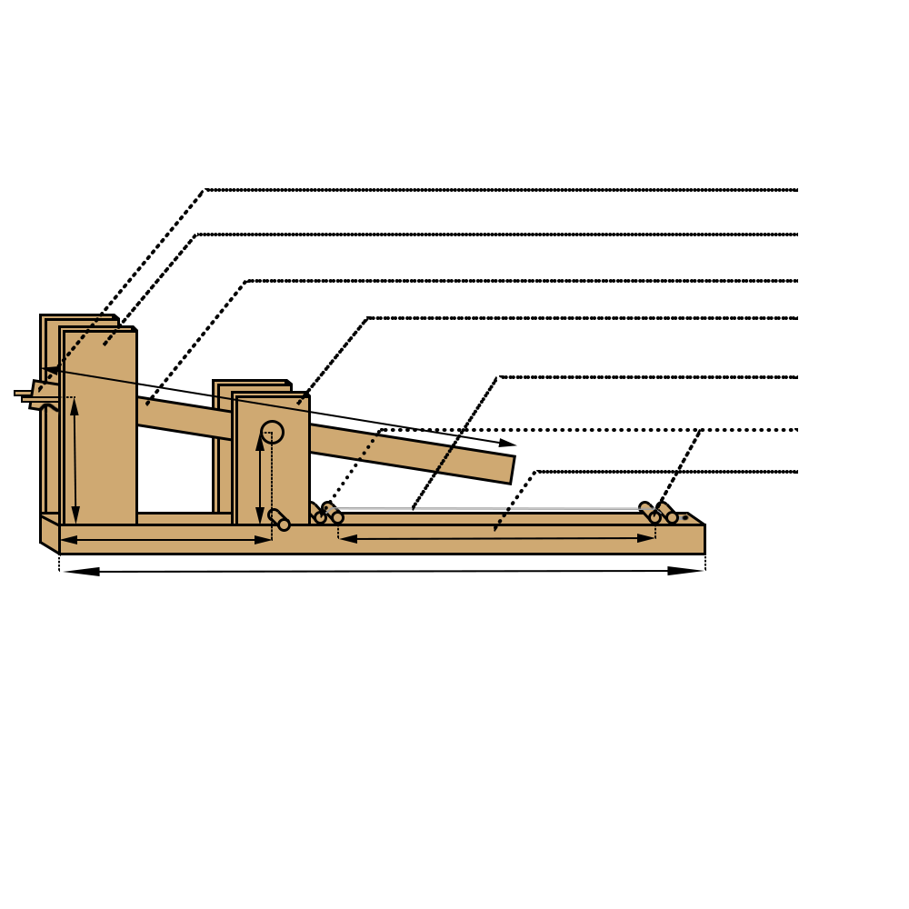

Back Board

Pressure rod

String

First Shelf

Lever

Second shelf

Rubber band holder

Explaining the measurement

### Controlled Variables

|  |  |  |
| --- | --- | --- |
| ­­­Name | significance | control |
| Tension and length of the string | The amplitude of the displacement of the center of the string is dependent on the length of the string and the tension force in the string. An increase in either tension or length of the string will decrease the amplitude of vibration. | I tied the string onto a knob which is in the structure. The knob’s friction holds the tension and length of the string constant, and it also enables me to adjust the string if it has gotten loose. There is a mark on the knob which matches up with another knob on the structure to help during adjustment |
| Striking point on the string | The mathematical model which I built requires that the striking force is applied at the center of the string. If the striking force is not applied at the center, the angle change of the two ends of the string would be different, which will cause my math model to fail. | I built a lever to strike the string in order to solve this issue. With this structure, it makes sure that every time the striking force is applied at the center of the string. |
| Gain of the microphone | The gain of the microphone will directly affect the output voltage of the microphone, because if the microphone can be manipulated by the gain of the microphone. A compensation can be made if value is not kept constant by recording the gain of each recording and doing different calculations for each trial. | The gain of the microphone have been adjusted to the lowest possible gain of the microphone of 1V to make sure that the data does not get affected by the equipment. |
| Stability of the two ends of the string | Movement at the ends of the string will cause energy loss in the system, which takes away power from the sound produces. This causes the intensity (loudness) of the sound to decrease | Two sticks were added on each of the ends of the string: one to apply pressure on the string to minimize movement, other one to levitate the string above backboard to give space for the jack to produce the amplitude. |
| Loudness of the room | Sound in the room which the experiment is conducted will increase the measured intensity of the sound, which will cause inaccuracy in the result of the experiment. | I went to a separate small room to record the audio with minimal background noise. |
| Expansion length of rubber band | If the rubber band is stretched to different length, it will have different potential energy, which will produce different amount of forces. The change in the force striking the string would cause the independent variable to be inaccurate, and thus will make the measurement unreliable. | I measured the length which a rubber band needs to expand in order to produce 1 N of fore. I kept the value in mind when I was building my structure, and I designed it so that the maximum amount of room which the lever can move at the end is the length of the rubber band after stretched with 1N of force. |
| Elasticity of the rubber band | If one rubber band have been stretched under force for multiple times, it my loose elasticity. When I was experimenting to find the length of the rubber band to produce 1N of force, I increased the resting length of the rubber band that I was using by a few centimeters after I finished testing. The elasticity will directly change the force striking the string, which is my independent variable. | To make sure that every rubber band is at its best state, I do not reuse any of the rubber band, and I will try put each rubber band under stress for the least time as possible by quickly releasing them. |

### Procedure

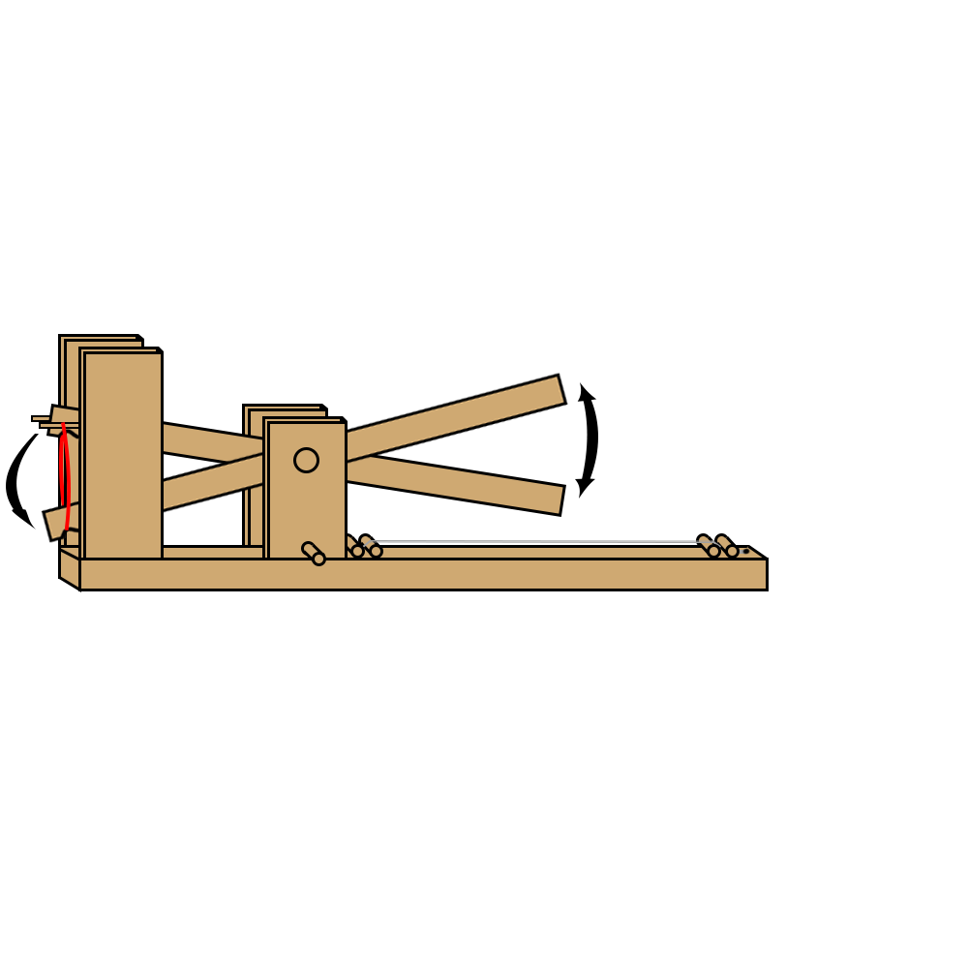First, I adjusted the turned the adjusting knob until the string lied straight but have no tension. I then turned the knob an extra 180 degrees to add extra tension onto the string. I then moved into a quiet room to reduce background sound. After, I placed a microphone with minimum gain as close to the middle of the string as possible. I then attached the microphone to my computer and started recording with audition. I then attached one rubber band onto the holder and the end of the lever. I pressed the lever down to the bottom and released it five times (each time with new rubber bands) to gather five sets of results for the loudness produced by one rubber band. I then repeated the process from recording to pressing the lever for 2, 3, 4, 5, 6, 7, and 8 rubber bands, each one with five trials, and every trial using new rubber bands.

## Hypothesis

### Variables

|  |  |  |  |  |
| --- | --- | --- | --- | --- |
| Variable | Meaning | Unit | Value | Method of obtain |
| $$I$$ | Intensity | $$W/{m^{2}}$$ | Variable | Calculate |
| $$p$$ | Sound pressure | $$Pa$$ | Variable | Calculate |
| $$v$$ | Particle velocity | $$m/s$$ | Variable | Calculate |
| $$ω$$ | Angular frequency | $${rad}/s$$ |  | Calculate |
| $$a$$ | Amplitude (particle displacement) | $$m$$ | Variable | Calculate |
| $$μ$$ | Density of medium in which sound is traveling | $${kg}/{m^{3}}$$ | 1.225 | Research online |
| $$c$$ | Speed of wave (sound) | $$m/s$$ | 343 | Research online |
| $$f$$ | frequency | $$Hz$$ | 485 | Computer measure |
| $$π$$ | Ratio of circumference to diameter of a circle |  | 3.14159 | Research online |
| $$F_{t1}$$ | Original tension of the string | $$N$$ | TBD | Force meter measure |
| $$F_{t2}$$ | Tension of the string at equilibrium | $$N$$ | Variable | Calculate |
| $$F_{a}$$ | Force of the striking object | $$N$$ | Variable | Control |
| $$F_{v}$$ | Vertical component of the tension of the string | $$N$$ | Variable | Calculate |
| $$x$$ | Change in length of the string after tension is applied | $$m$$ | Variable | Calculate |
| $$k$$ | Spring constant of the string | $$N/m$$ |  | Calculate |
| $$l_{o}$$ | Original length of the string | $$m$$ | 0.3 | Ruler measure |
| $$l_{n}$$ | Length of the string when struck by the jack | $$m$$ | Variable | Calculate |
| $$p_{ref}$$ | Reference sound pressure of the microphone | $$Pa$$ | 120 | Manufacturer information |
| $$p_{rms}$$ | Root mean square of the amplitude of the recording | $$Pa$$ | Variable | Calculate |
| $$p_{dB}$$ | Sound pressure measured by the microphone | $$dB SPL$$ | variable | Microphone record |

### Deriving the formula

The loudness of sound is determined by its intensity, which can be expressed as: $I=pv$, which is the formula definition of sound intensity while intensity transferred by a wave can be described as $I=\frac{1}{2}ω^{2}a^{2}μc$, therefore $pv= \frac{1}{2}ω^{2}a^{2}μc$

Since angular frequency is just change in angle per second: $ω=2πf$, $I=\frac{1}{2}ω^{2}a^{2}μc=\frac{1}{2}{{(2πf)}^{2}a}^{2}μc={2π^{2}f^{2}a}^{2}μc$

The sound pressure level is best represented by the root mean square of the amplitude:

$p_{dB}= 20\log\left(\frac{p_{rms}}{p_{ref}}\right)dB$ => ${ p}_{rms}={10}^{\frac{p_{dB}}{20}}×p_{ref}$

Also, as the measured power is in decibel $P_{dBV}=10log⁡(\frac{P_{output}}{1})$ => $P_{output}={10}^{\frac{P_{dBV}}{20}}$

As $v=ωa=2πfa$, therefore: =>

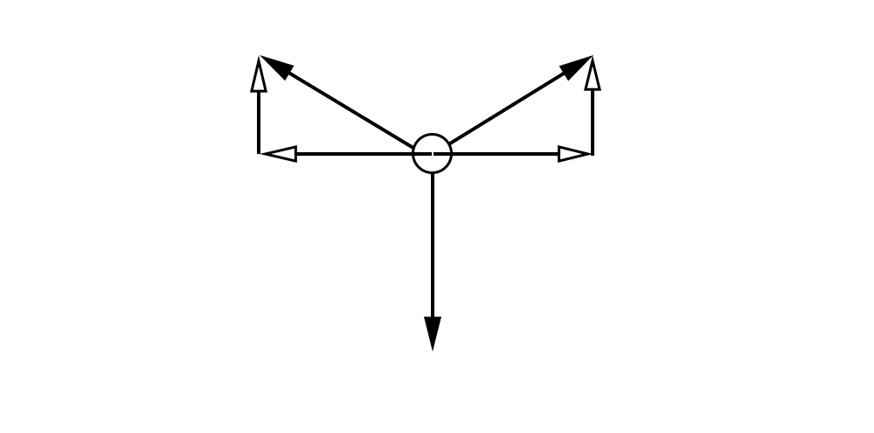

The amplitude is related to the tension force and the force pushing the string:

Since at the maximum displacement, the system would be in equilibrium,

${2×F}_{v}=F_{a}$, which means that $F_{t2}=\sqrt{{F_{t1}}^{2}+{(\frac{F_{a}}{2})}^{2}}$

Since $F_{t2}$ will be the final force on the string, the string will extend $x=\frac{F_{t2}}{k}=\frac{\sqrt{{F_{t1}}^{2}+{(\frac{F_{a}}{2})}^{2}}}{k}$ m

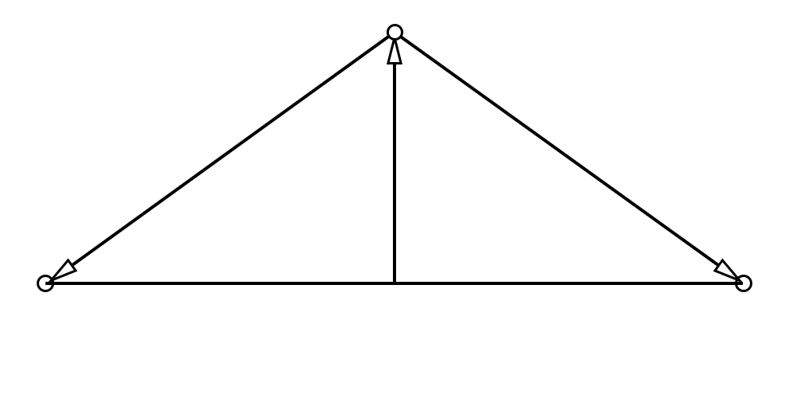

=> =>

After plugging the amplitude into the original equation and simplifying, we get $πf\sqrt{{(\frac{l_{o}k+\sqrt{{F_{t1}}^{2}+{(\frac{F_{a}}{2})}^{2}}}{2k})}^{2}-{(\frac{l_{o}}{2})}^{2}}μc={10}^{\frac{p_{dB}}{20}}×p_{ref}$

However, because Young’s modulus sates $F=\frac{EA∆l}{l_{o}}$ and that $F=kx$ with $∆l$ and $x$ both being the change in length,

Therefore $kx=\frac{EA∆l}{l_{o}}$ which can be simplified to $k=\frac{EA}{l_{o}}=\frac{Eπr^{2}}{l_{o}}$

Plugging both relationships back to the equation: ${10}^{\frac{P_{dB}}{20}}= πfaμc = πf\sqrt{{(\frac{l_{o}\frac{Eπr^{2}}{l_{o}}+\sqrt{{F_{t1}}^{2}-{(\frac{F_{a}}{2})}^{2}}}{2\frac{Eπr^{2}}{l_{o}}})}^{2}-{(\frac{l_{o}}{2})}^{2}}μc$

After simplifying the equation, the relationship becomes: $πf\sqrt{{(\frac{Eπr^{2}l_{o}+l_{o}\sqrt{{F_{t1}}^{2}+{(\frac{F_{a}}{2})}^{2}}}{2Eπr^{2}`})}^{2}-{(\frac{l_{o}}{2})}^{2}}μc={10}^{\frac{p_{dB}}{20}}×p_{ref}$

## Data Analysis

### Raw Data

#### Table 1:

##### Microphone recorded loudness (dB SPL) depending vs forces applied (N)

|  |  |  |  |  |  |  |  |  |
| --- | --- | --- | --- | --- | --- | --- | --- | --- |
| # of rubber bands | 1 | 2 | 3 | 4 | 5 | 6 | 7 | 8 |
| Force applied | 1 | 2 | 3 | 4 | 5 | 6 | 7 | 8 |
| Trial 1 | -19.85 | -14.95 | -13.57 | -16.58 | -11.23 | -7.83 | -7.89 | -7.58 |
| Trial 2 | -13.02 | -14.10 | -13.94 | -11.61 | -8.93 | -8.85 | -7.17 | -3.10 |
| Trial 3 | -18.38 | -17.82 | -15.49 | -14.32 | -14.72 | -7.90 | -15.15 | -6.95 |
| Trial 4 | -21.05 | -17.65 | -18.69 | -14.15 | -9.91 | -12.07 | -7.49 | -6.35 |
| Trial 5 | -23.3 | -14.78 | -11.86 | -10.08 | -11.57 | -9.72 | -6.77 | -7.52 |
| Trial 6 | -19.67 | -15.16 | -14.69 | -13.02 | -11.89 | -11.16 | -11.00 | -6.95 |
| Trial 7 | -19.43 | -21.17 | -17.73 | -14.63 | -11.57 | -12.63 | -8.58 | -4.73 |
| Trial 8 | -21.08 | -20.29 | -18.83 | -10.77 | -12.85 | -10.83 | -10.74 | -8.73 |
| Trial 9 | -22.27 | -14.61 | -14.64 | -15.68 | -10.15 | -9.58 | -7.81 | -7.11 |
| Trial 10 | -20.29 | -17.15 | -18.04 | -11.70 | -15.76 | -12.23 | -9.68 | -7.16 |
| Trial 11 | -22.72 | -22.96 | -12.92 | -11.79 | -10.77 | -12.29 | -9.17 | -7.45 |
| Trial 12 | -21.61 | -16.33 | -16.06 | -13.66 | -10.56 | -7.34 | -7.73 | -9.23 |
| Trial 13 | -21.61 | -19.22 | -20.40 | -16.58 | -7.69 | -12.05 | -9.95 | -8.21 |
| Trial 14 | -25.40 | -19.87 | -12.20 | -14.62 | -10.23 | -10.77 | -6.87 | -7.12 |
| Average | -20.69 | -17.576 | -15.65 | -13.51 | -11.27 | -10.38 | -9.00 | -7.01 |

#### Data calculation:

Force: Since each rubber band stores 1 N of force, the amount of force striking the string would be equal to the amount of rubber band used.

#### Uncertainty Calculation

This is the formula which I will fallow when calculating the uncertainty: $u_{total}=u_{measurement}+u_{human}+u_{formula}$

Since Audition measures the loudness in dB up to 2 decimal places, the measurement uncertainty would be $±0.01$

The human uncertainty will be determined by the difference between the average and the maximum and minimum values in the data set: the greater difference will be taken as the uncertainty

The formula uncertainty is for the consideration of the uncertainty of the constants used in my model, which gives the equation uncertainties. This uncertainty will be calculated using the theory’s formula:

Sample calculation:

#### Graph

### Y axis only processed data

#### Table

#### Data calculation

#### Uncertainty calculation

#### Graph

### X and Y axis processed data

#### Table

#### Data calculation

#### Uncertainty calculation

#### Graph

### Summary

## Evaluation

### Safety

1. The rubber band might slide off the holder, and hit people around.

Carved a curve into the holder and the jack to keep the rubber band in place.

1. String may snap if under too much tension and hit people in the hand.

Research the maximum tension on the string and make sure that the tension placed on the string does not exceed the maximum tension capacity of the string.

1. Experiment involve movement of big objects (the jack), and may hit people’s hand if close by.

Make sure that the area of the experiment is clear of people before starting the experiment, and rounded off corners of the jack to minimize damage if there are people within the radius of the jack.

### Sources of error

|  |  |  |
| --- | --- | --- |
| Source of error | Significance | Method to improve |
| Constants used for calculation | My calculations involve Young’s modulus, which is a value that is different depending on the material and the temperature. The string which I used have high carbon as the core. However, the actual ratio between carbon and iron have not been specified, thus the actual Young’s modulus of the string is different from what I have used to perform my calculation. | Use a string made out of a pure element or have a recorded Young´s modulus. |
| Measuring device | While a professional recording software is used, the computer sound card may have slightly amplified the signal when processing it, causing the reading to be slightly bigger than the real loudness. | Calibrate the computer sound card or use a decibel meter to record the loudness of the sound |
| Structure instability | More than one frequency has been found when analyzing the recorded. This means that not all of the energy generated by the jack have been transferred into one single wave. This causes the actual loudness to be smaller than what the formal predicts. | Leave more room around the wire and connect the components tighter so they do not vibrate together with the string. |
|  |  |  |

## Conclusion